Lee’s Incremental Cube Solution

Stage 1: Learn to Complete It
- Form a cross on the top layer
- Bring in the corners to complete the top layer
- Use Fridrich’s “insert the edge and preserve the corner” [1] technique (and its inverse) on each edge. If an edge is already in there (but flipped,) use the technique to put another edge there.
Pattern | Algorithm(s)
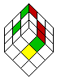 | 8) [D] F D' F' D' R' D R

- Use Knights’ 2 “orient edges” [2] techniques to orient the edges.
probability: 1/2  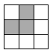  1. F U R Ui Ri Fi =[A] | probability: 1/4  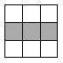  2. F R U Ri Ui Fi =[B] | probability: 1/8  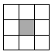  3. [B] (U2) [A]

- Use Knights’ “position corners” [2] technique to position the corners.
probability: 2/3  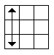  1. Ri U L Ui R U Li U2 | probability: 1/6  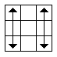  2. L U2 Li Ri U L Ui R U2 Li

- Use Lars’ “Sune” [3] technique to twist the corners.
- Use Lars’ “Allan” [4] technique to permute the edges.

Expected average: 110 seconds
Memorization load: 6 algorithms

Stage 2: Improve your “permute the edges” technique
- Use Knights’ “permute edges” [2] technique to permute the edges
probability: 2/3  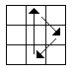  1. R2 U F Bi R2 Fi B U R2 | probability: 1/12  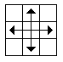  2. R2 L2 Di R2 L2 U2 R2 L2 Di R2 L2 | probability: 1/6  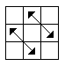  3. L Ri D2 U2 L Ri D L2 R2 Ui B2 F2

Expected average: 95 seconds
Memorization load: 3 new algorithms (8 total.)

Stage 3: Improve your “twist corners” technique
- Use the following mix of Knights’ “orient corners” [2a][[2b] techniques to orient the corners

probability: 4/27  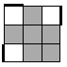  1. Ri U2 R U Ri U R =[C] | probability: 4/27  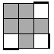  2. [C]i | probability: 4/27  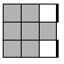  3. [C] (U) [C]i | probability: 4/27  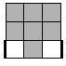  4. [C] (Ui) [C]i
probability: 4/27  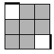  5. [C] (U2) [C]i | probability: 4/27  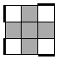  6. R U2 R2 Ui R2 Ui R2 U2 R | probability: 2/27  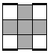  7. Ri U2 R U Ri Ui R U Ri U R

Expected average: 80s
Memorization load: 7 new algorithms (14 total.)

Stage 4: Improve your “top 2 layers” technique
- Learn Fridrich’s techniques for the top 2 layers [1].

Expected average: 30 seconds
Memorization load: 22 new algorithms

References
[1] – http://www.ws.binghamton.edu/fridrich/Mike/middle.html
[2a] - http://benjerry.middlebury.edu/~knights/Cube/Intermediate.html
[2b] – http://benjerry.middlebury.edu/~knights/Cube/Advanced.html
[3] – http://lar5.com/cube/fas6.html
[4] – http://lar5.com/cube/fas7.html

